**BAKERY SALES ANALYSIS**

**PROJECT DESCRIPTION:**

The goal of this analysis is to evaluate the sales performance of a bakery and identify areas for improvement to maximize revenue. The bakery's sales data was collected for the year 2010 and includes information on product sales, sales channels, and the number of orders placed.

The analysis begins by examining the overall performance of the bakery, including the total revenue generated, the number of orders placed, and the range of products offered. This will help determine the bakery's strengths and identify any areas that need improvement.

The analysis then focuses on the sales performance of each product, including their revenue, popularity among customers, and the price charged for each item. By examining the relationship between revenue and orders, we can identify opportunities to maximize revenue across all products and determine which products are most profitable.

We will also examine the trend in revenue over time and compare it to other key performance indicators, such as customer acquisition and retention rates, to determine if the increase in revenue was due to increased customer engagement.

Lastly, we will analyze the sales channels and compare their revenue performance. By examining the reasons behind the high revenue generated by Counter orders, Phone orders, and Online orders, we can identify opportunities to increase sales and optimize sales channels.

Finally, this analysis will provide valuable insights for the bakery to maximize revenue and improve its sales performance.

**INSIGHTS:**

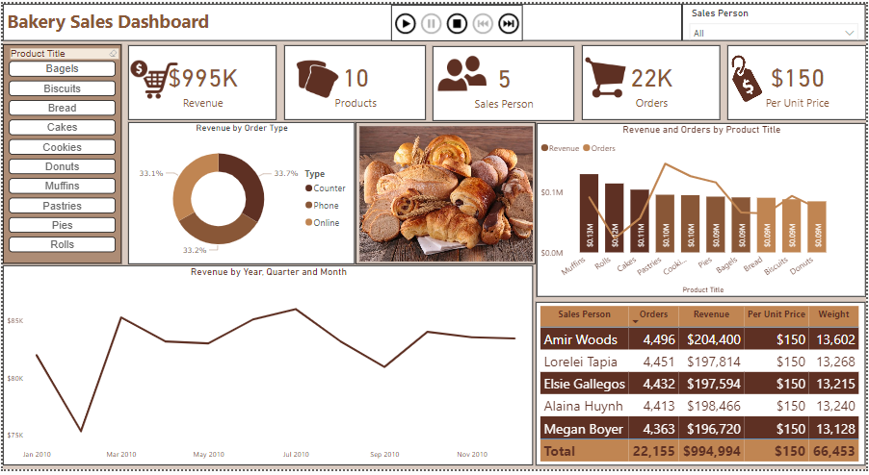

**What is the bakery's sales performance and capacity to handle customer demand?**

The bakery's sales performance is impressive, having generated a total revenue of 995k from 22k orders. This indicates a healthy demand for their products. The bakery's range of over 10 different types of products also suggests that they have a diverse product line that caters to a wide range of customers.

Moreover, with 5 salespersons, it appears that the bakery has a well-organized sales team that can effectively handle the orders and keep up with the demand.﻿

**What is the revenue and order breakdown by product for the bakery?**

Among all the products sold, Muffins generated the highest revenue of $131,020, which was 53% higher than the lowest revenue generated by Donuts at $85,475. Muffins also accounted for 13% of total revenue, indicating that they are a popular choice among customers.

Interestingly, when looking at the relationship between revenue and orders, there was a significant deviation for Muffins, revenue exceeded orders by $128,797. This could indicate that the bakery is able to charge a high price for their muffins, because there is a high demand for them that allows for some price flexibility.

It would be beneficial to determine if there are any opportunities to maximize revenue across all products. Additionally, the bakery may want to consider investing more resources into the production of Muffins to meet the high demand and capitalize on their popularity among customers.

**What was the trend in revenue for the business in 2010?**

The revenue of the business showed a positive trend, with an increase of 1.79% observed between January 2010 and December 2010. This indicates a growth in the business's ability to generate revenue during the period. The bakery generated the highest sales in July 2010 and the lowest sale in February 2010

Since there is no customer data, it would be beneficial to compare the revenue trend with other key performance indicators, such as customer acquisition and retention rates, to determine if the increase in revenue was a result of increased customer engagement. By examining multiple performance indicators, the business can gain a more comprehensive understanding of its growth and identify areas for improvement.

**What is the revenue breakdown by order type for the Bakery?**

The Bakery's revenue was highest for Counter orders, which generated $335,048 in revenue, followed closely by Phone orders at $330,619 and Online orders at $329,327.

Further analysis of the data could reveal the reasons behind the counter order’s higher revenue, such as its accessibility to customers, the effectiveness of the business's in-person sales techniques, or higher profit margins on counter orders. This information could help the bakery to determine if there are opportunities to increase sales further by promoting counter sales or optimizing other sales channels.

**CONCLUSION:**

The bakery's sales performance is impressive, with a diverse product line and a well-organized sales team catering to healthy demand. Muffins are the most popular product generating high revenue and profit margins. The business can explore opportunities to maximize revenue across all products and invest more in muffin production to meet high demand. The highest revenue came from counter orders, and further analysis could reveal ways to optimize other sales channels. The positive revenue trend indicates growth, and examining other KPIs could help identify areas for improvement.